There will be a four-point quiz at the beginning of lab each week that will cover the current and previous lab. (Pre- and Post-lab questions) Thus, there will be 2 pre-lab questions and 2 post-lab questions for a total of 4 points per week (most weeks). Questions will cover information found in the lab manual, the slides associated with the lab, and the textbook.

Lab 8
Animal Phylogeny and Bioinformatics

Pre-lab Questions
1. Name 3 of the animal skeleton species that we will examine in lab today. Any of the nine
2. What program will be used to align the sequences for the molecular phylogeny? MEGA
3. Will we use morphological, molecular, or both types of data to make phylogenetic trees today? Both
4. The phylogenetic trees that we construct are hypotheses, true or false?
5. Phylogenetic trees based on morphological or molecular data use different characters to compare between groups. Describe why, or why not, one method is better than the other. Many answers are possible. Some examples include: Molecular data often include a greater number of characters, which may increase the power. However, the loci chosen can bias results. Morphological characters can be similar but have very distant relationships because of convergent evolution, which would decrease accuracy. They may also say that neither is really better and/or that both should be used.

Post-lab Questions
1. We created phylogenetic trees to examine the evolutionary relationship between vertebrate species. Explain why our two trees based on morphological and molecular characters were or were not the same. Different characters and number of characters were used.
2. What is the purpose of conducting a multiple sequence alignment? So that comparisons between sequences are actually comparing similar characters (positions along the DNA sequence) among individuals/taxa.
3. Which skeleton had an extra thumb? Mole
4. Which of the morphological characteristics we examined was unique to mammals and present in all three mammals? Dentary-squamosal jaw articulation
5. Based on the molecular animal phylogeny, what was the closest relative of a turtle? Bird
6. Of the nine animal taxa studied in the previous lab, which did we use as the outgroup to root the tree of our animal phylogeny? Fish
7. Which animals had canine teeth of those studied? Cat and mole
8. Which animals had four digits on the forelimbs? Frog and salamander
9. Which animal had a carapace? Turtle

Lab 9
Comparative Vertebrate Anatomy
Pre-lab Questions
1. Which one of the organisms in today’s lab has a swim bladder? Fish
2. What are the 3 organisms that we will dissect and compare in today’s lab? Fish, frog, rat
3. Which 3 organs will we be measuring today? Heart, stomach, small intestine
4. What type of food is more common in the diet of organisms with longer intestines?
Plant material
5. Are fish and frogs ectotherms or endotherms? Ectotherms
6. Which of the organisms dissected today has a single circulation system? Fish
7. When writing a null hypothesis, what is the effect of the treatment? Null hypotheses propose there is no effect of treatment
8. What does ectotherm and endotherm mean? Ectotherm means heat is gained from the environment. Endotherm means heat is produced internally.

Post-lab Questions
1. Which dissected animal from the previous lab has just two chambers in its heart (choose just one species)? Fish
2. Which organism had the largest stomach? Frog
3. A relatively large stomach would work well for an organism that eats small meals frequently, true or false?
4. Why do some organisms have a cecum? To harbor bacteria that help digest cellulose (and absorb remaining nutrients and water).
5. Fish and frogs are ectotherms. Name one advantage ectotherms have over endotherms.
Ectotherms need less food per body size than endotherms. A greater proportion of food energy can be used for growth and reproduction.
6. Name 3 organs that were all present in the fish, frog, and mammal. This may include many organs.
7. Which one of these gastrointestinal tracts is least likely to belong to a carnivore? A is the answer because it has the shortest small intestine.
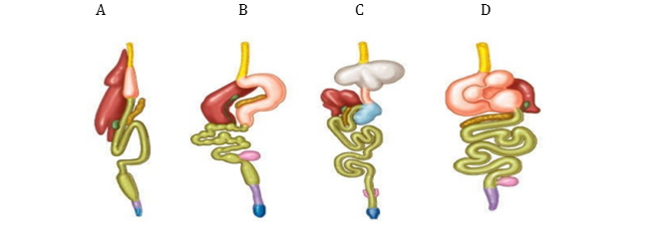

Lab 10
Animal Evolution and Diversity I
Pre-lab Questions
1. What are three of the five phyla we cover in today’s lab?
Porifera, Cnidaria, Platyhelminthes, Annelida, and Mollusca. They must have three of the five.
2. Is it possible for some organisms to breathe through their skin? Yes. In these five clades, only Mollusca does not use skin to breathe (at least not as it’s main source of O2). All they need is yes, however.
3. Name one organism that belongs to the phylum Platyhelminthes (clade Lophotrochozoa).
Planaria is what most will state, but it could be many others. You may have to look it up.
4. What is the difference between a cavity and a canal? Cavity’s entrance and exit is the same. Canal is a one way trip through an entrance and out a different exit.
5. What is the general function of a kidney? To collect waste products and finally excrete them out of the body.
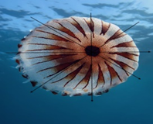
6. Define bilateral symmetry. Symmetrical in two halfs.
7. This is a picture of a jellyfish. What type of symmetry does it have?

Radial symmetry
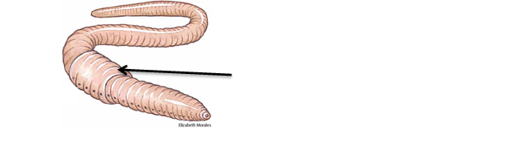
8. What is this exterior part of the earthworm called?
Clitellum

Post-lab Questions
1. Which of the following excretory organs works most like the human kidney: malpighian tubes or metanephridium?
2. What type of circulatory system is present in a clam (diffusion, open, or closed)? Clams have an open circulatory system, but the clade contains both (cephalopods have closed).
3. What is the name of the free swimming stage and the attached or stationary stage in Cnidarians? Medusa
4. What phylum does a clamworm belong to? Annelida
5. What phylum does a sponge belong to? Porifera
6. Do earthworms contain just male reproductive organs, just female reproductive organs, or both? Both
7. What is the structure in a mollusc that secretes the shell? Mantel
8. Name two of the three different types of body cavity. Coelom, pseudocoelom, acoelom
9. Is an earthworm more closely related to a clam or a planarian? Clam

Lab 11
Animal Evolution and Diversity II
Pre-lab Questions
1. Are humans included in one of the phyla we are studying today? Yes, we are in Chordata.
2. Name two habitats occupied by arthropods. Any habitat because they are in every habitat.
3. Describe the function of the gastric ceca in a grasshopper. Hint: the organ connects the crop to the stomach.
The gastric caeca aids in digestion by increasing surface area, digestive enzyme secretion, and nutrient absorption. Something to that effect.
4. What phylum does a lancelet belong to? Chordata
5. What are the four phyla we cover in today's lab? Nematoda, Arthropoda, Echinodermata, Chordata
6. What kind of symmetry does a sea star have?
Radial symmetry (as adult), bilateral as larva. They only need radial.
7. What structure allows sea stars to take water into their vascular system? Madroporite
8. What is the function of an exoskeleton? Support, protection, hold everything in (and more).

Post-lab Questions
1. What is the difference between an open and a closed circulatory system?
Closed system includes vascularization to move blood around body and organs. Open system has blood/lymph circulating freely around the organs.
2. Name 3 different type of respiratory organs. Skin, gill, lungs, spiracle
3. What is the difference between the aboral and oral surface of a sea star?
Oral surface is the bottom side where the mouth is present. Aboral is the top side where the anus is present.
4. What type of circulatory system is present in a crayfish (diffusion, open, or closed)?
5. What type of digestive tract was present in the sea star we dissected (gastrovascular cavity, alimentary canal, or other)?
6. Name two phyla that make up a sister clade on the phylogeny you created.
Mollusca-Annellida; Nematoda-Arthropoda; or Chordata-Echinodermata
7. What type of excretory organs does a roundworm have? Lateral lines
8. What type of circulatory system is present in a human (diffusion, open, or closed)?
9. What is the name of the structure indicated on the crayfish below? Walking legs
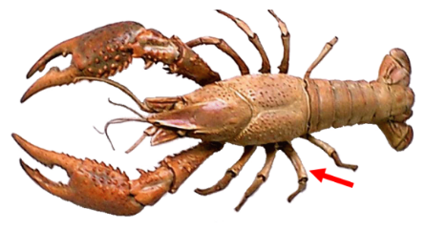

10. What is the name of the structure indicated on the starfish below? Tube feet
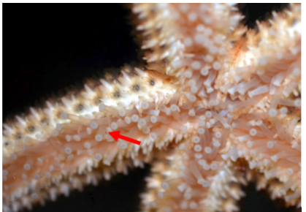

Lab 12
Presentations on Phyla and Scientific Paper

We will NOT have a quiz associated with or during the week of this lab.

Lab 13
Invasive Plant Ecology and Bioinformatics
Pre-lab Questions
1. Today, are we aligning DNA sequences to build phylogenies or to compare haplotypes?
2. Why are we interested in distinguishing between varieties of Phragmites plants?
To identify which samples are native and which are invasive varieties.
3. As defined by your lab notebook, what is an introduced species?
A species outside of its native geographic range.
4. What is a plant rhizome?
Underground lateral stems that produce new plants with identical DNA.
5. Does an invasive species usually have a positive or negative impact on other plant and animal species? Negative
6. Define a haplotype. A specific sequence of DNA at a locus. Different haplotypes are variants in the sequence.
7. What is the difference between a point mutation and an insertion-deletion mutation?
Point mutation are differences in a single base pair and insertion-deletions are regions with extra or missing base pairs.
8. What is an introduced species and how does it compare to an invasive species?
Introduces species are outside of their native range, whereas invasive species are introduced species that successfully establish a population.
9. What is an example of an invasive species (write the name of one invasive species)? Many answers are acceptable.

Post-lab Questions
1. Are native or nonnative Phragmites australis haplotypes more likely to form monocultures?
Nonnative
2. Why is an examination of sequences a necessary step when the goal is to determine a restriction enzyme that will differentiate native and nonnative haplotypes?
a) Necessary to determine that restriction enzyme will create DNA sequences of different lengths for native and nonnative haplotypes
b) Necessary to determine that unknown samples are not new haplotypes and instead match exactly to known haplotypes
c) Both a and b
d) None of the above
3. What does PCR stand for? Polymerase chain reaction
4. What does intergenic mean? Between genes
5. Name a characteristic that allows a species to become invasive. There are many. Most notable are generalist, high fecundity.
6. Was the non-native or native haplotype more common in the samples taken from Utah?
Non-native was more common in our samples.
7. Why is it necessary to align sequences before they are compared?
Because base pair positions are compared, so we must align sequences to compare identical positions.
8. What does RFLP stand for? Restriction Fragment Length Polymorphism
9. Explain why non-native plants species that have rhizomes have more potential to become invasive. They can reproduce vegetatively very fast.
Lab 14 (Spring) or Lab 3 (Fall)
Prairie Biodiversity and Ecology

We will NOT have a quiz associated with or during the week of this lab because it is in the field at Glacier Creek Preserve.

Lab 14 (Fall) or Lab 3 (Spring)
Microbes and Ecosystem Ecology

Pre-lab Questions
1. What gas is produced during microbial respiration (this is the gas we will measure today)? CO2
2. Are microorganisms in soil heterotrophic or autotrophic? Heterotrophic
3. Where did we collect the soil that we will use in lab today? Glacier Creek Preserve
4. Should an increase in temperature increase or decrease the rate of respiration? Increase
5. Should an increase in moisture increase or decrease the rate of respiration? Increase
6. At what setting should we place the CO2 sensor that we will use today? Low
7. What is the independent variable in today’s lab? Environment, or temperature and moisture
8. Organic carbon is evenly distributed across the globe, true of false?

Post-lab Questions
1. Is there typically more soil organic carbon in soils near the equator or near the poles of the earth? Near the poles
2. Soil contains more organic carbon than the atmosphere, true or false?
3. Why do we find more soil organic carbon at some latitudes than others? Environmental variables associated with latitude such as temperature and moisture affect carbon sequestration and metabolic rates of respiration.
4. What is the approximate level of CO2 in our Earth’s atmosphere? 400 ppm
5. What was the dependent variable in our soil respiration experiment? CO2
6. Briefly explain why changes in temperature may affect soil respiration rates? Higher temps increase metabolism and respiration rates.
7. Briefly explain why changes in moisture may affect soil respiration rates? Higher moisture content increases metabolism and respiration rates.

